CS261 ASSIGNMENT 2

NAME:

ARCHIT AGRAWAL

ROLL NO. :

202052307

SECTION:

A

1. **Prepare a Class diagram for all the questions given in Assignment 1.**

Q.1

|  |
| --- |
| **PalindromeCheck** |
| + num: int |
| + PalindromeCheck() |
| + reverse(n : int): int  + isPalindrome(n : int): boolean  + main(args : String[]): void |

Q.2

|  |
| --- |
| **Reverse** |
| + revRec: int |
| + Reverse() |
| + reverseLoop(n : int): int  + reverseRecursion(n : int): int  + main(args : String[]): void |

Q.3

|  |
| --- |
| **LinearSearch** |
| + LinearSearch() |
| + search(arr : int[], num: int): int  + main(args : String[]): void |

Q.4

|  |
| --- |
| **Room** |
| + roomNo: int  + roomType: String  + roomArea: double |
| + Room()  + Room(number: int) |
| + setData(num: int, type: String, area: double): void  + displayData(): void  + main(args : String[]): void |

1. **Differentiate between Methods and Constructor. Write a program in JAVA to find the area of circle using constructor.**

**Constructors** -: Constructors are used to initialize the object’s state. A constructor also contains collection of statements that are executed at time of Object creation. Each time an object is created using ‘new’ keyword at least one constructor is invoked to assign initial values to the instance variables of the same class.

**Methods** -: A method is a collection of statements that perform some specific task and return the result to the caller. A method can perform some specific task without returning anything. Methods allow us to reuse the code without retyping the code.

|  |  |
| --- | --- |
| **Methods** | **Constructors** |
| A Method is a collection of statements which returns a value upon its execution. | A Constructor is a collection of statements that initializes a newly created object. |
| A Method consists of Java code to be executed. | A Constructor can be used to initialize an object. |
| A Method is invoked by the programmer. | A Constructor is invoked implicitly by the system. |
| A Method is invoked through method calls. | A Constructor is invoked when an object is created using the keyword ‘new’. |
| A Method does operations on an already created object. | A Constructor initializes an object that doesn’t exist. |
| A Method must have a return type. (it may be void) | A Constructor doesn’t have a return type. |
| A Method’s name can be anything. | A Constructor’s name must be same as the name of the class. |
| A class can have many methods but must not have the same parameters. | A class can have many Constructors but must not have the same parameters. |

*Code to find area of circle using constructor*

*Class Diagram*

|  |
| --- |
| **Area** |
| + area: double |
| + Area(r: double)  + Area(l: double, b: double) |
| + areaOfCircle(r: double): double  + areaOfRectangle(l: double, b: double): double  + main(args: String[]): void |

**Approach**: Here, a class Area is written which has area as its instance variable. Two different constructors for the area class are written, constructor 1 takes only one parameter and assigns the area of circle in the instance variable ‘area’. Constructor 2 takes two parameters and assigns the area of rectangle in the instance variable ‘area’. In the ‘main’ method, an object ‘circle’ of class Area is created using constructor 1. On printing the instance variable ‘area’ for this object its area is printed. After that area of circle is also found using the method ‘areaOfCircle’.

import java.util.*;

public class Area{

    double area; //instance variable of class Area

    //constructor that finds the area of a circle

    public Area(double r){ //constructor 1

        this.area = 3.14 * r * r;

    }

    //constructor that finds area of a rectangle

    //we can write as many constructors we want but they must have same name(the name of class)

    //constructor 2

    public Area(double l, double b){ //each constructor must have different parameters

        this.area = l * b;

    }

    //method that finds the area of a circle on taking radius as input

    //method must have a return type

    public double areaOfCircle(double r){ //name of method can be anything

        return 3.14 * r * r;

    }

    //method that finds area of a rectangle taking length and breadth as input

    public double areaOfRectangle(double l, double b){

        return l * b;

    }

    public static void main(String[] args){

        Scanner sc = new Scanner(System.in);

        //creating an  object circle of class Area using constructor 1

        Area circle = new Area(7);

        System.out.println("Finding area of circle using constructor...");

        System.out.println("Area of circle (in unit square) : "+ circle.area);

        System.out.println();

        System.out.println("Finding area of circle using method areaOfCircle...");

        System.out.println("Area of circle (in unit square) : "+circle.areaOfCircle(9));

        System.out.println();

    }

}

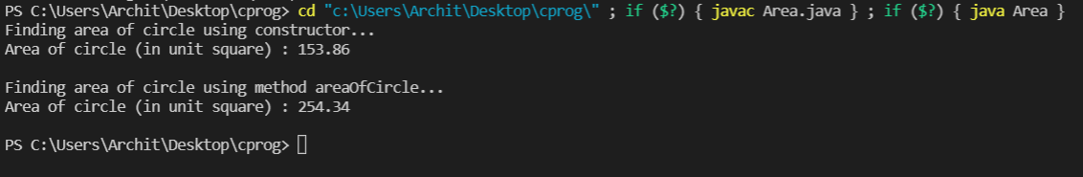 **Output**

1. **Write a program in JAVA to input details of student name, enrolment number, and marks in Science, Maths and English. And print all the details along with their percentage as output.**

*Class Diagram*

|  |
| --- |
| **Student** |
| + name: String  + enrolmentNo: int  + marksInScience: int  + marksInMaths: int  + marksInEnglish: int  + maximumMarks: int |
| + Student()  + Student(s: String, n: int, m1: int, m2: int, m3: int, mm: int) |
| + inputDetails(): void  + displayDetails(): void  + percentage(): double  + main(args: String[]): void |

***Approach***: Here, a class Student has been created with 6 instance variables “name, enrolmentNo, marksInScience, marksInMaths, marksInEnglish, maximumMarks” that stores the details of a particular student. Two constructors are written for creating a new object. The default constructor doesn’t provide any input about the student’s details while the constructor 1 takes all the details of the student while creating the object itself.

To take input about the students details a method ‘inputDetails’ is written. It takes the details from the user and stores it accordingly.

To display the details of student (which I have called as report card) a method ‘displayDetails’ have been written. It simply shows the details of a student in a decent way.

The method ‘percentage’ is written to calculate the percentage marks obtained by a particular student.

***CODE***

import java.util.*;

public class Student{

    //instance variables

    String name;

    int enrolmentNo;

    int marksInScience;

    int marksInMaths;

    int marksInEnglish;

    int maximumMarks;

    //default constructor

    public Student(){

        this.name = "";

        this.enrolmentNo = -1;

        this.marksInScience = -1;

        this.marksInMaths = -1;

        this.marksInEnglish = -1;

        this.maximumMarks = -1;

    }

    //constructor that takes all the details (constructor 1)

    public Student(String s, int n, int m1, int m2, int m3, int mm){

        this.name = s;

        this.enrolmentNo = n;

        this.marksInScience = m1;

        this.marksInMaths = m2;

        this.marksInEnglish = m3;

        this.maximumMarks = mm;

    }

    public void inputDetails(){

        System.out.println();

        Scanner sc = new Scanner(System.in);

        System.out.print("Enter Student's Name : ");

        name = sc.nextLine();

        System.out.print("Enter Student's Enrolment No. : ");

        enrolmentNo = sc.nextInt();

        System.out.print("Enter Student's marks in Science, Maths and English (separated by space or new line) : ");

        marksInScience = sc.nextInt();

        marksInMaths = sc.nextInt();

        marksInEnglish = sc.nextInt();

        System.out.print("Enter Maximum Marks : ");

        maximumMarks = sc.nextInt();

        System.out.println();

    }

    public void displayDetails(){

        System.out.println();

        System.out.println("********** Report Card **********");

        System.out.println();

        System.out.println("Name             : " +name);

        System.out.println("Enrolment No.    : " +enrolmentNo);

        System.out.println("Marks in Science : " +marksInScience +"/"+maximumMarks);

        System.out.println("Marks in Maths   : " +marksInMaths +"/"+maximumMarks);

        System.out.println("Marks in Science : " +marksInEnglish +"/"+maximumMarks);

        System.out.println("Percentage       : " +String.format("%,.3f", this.percentage()));

        System.out.println();

        System.out.println("*********************************");

        System.out.println();

    }

    public double percentage(){

        int marksAchieved = marksInScience + marksInMaths + marksInEnglish;

        int totalMarks = 3 * maximumMarks;

        return (marksAchieved * 100.0)/totalMarks;

    }

    public static void main(String[] args){

        System.out.println();

        System.out.println("Creating an object using default constructor...");

        Student s1 = new Student();

        System.out.println("Calling inputDetails method to take the details from the user...");

        System.out.println();

        s1.inputDetails();

        System.out.println();

        System.out.println("Calling displayDetails method to display the details of the student...");

        System.out.println();

        s1.displayDetails();

        System.out.println();

        System.out.println("Creating another object using the constructor 1...");

        Student s2 = new Student("Prakhar Awasthi", 1084, 48, 44, 37, 50);

        System.out.println("Displaying details of this object...");

        System.out.println();

        s2.displayDetails();

    }

}

***OUTPUT***

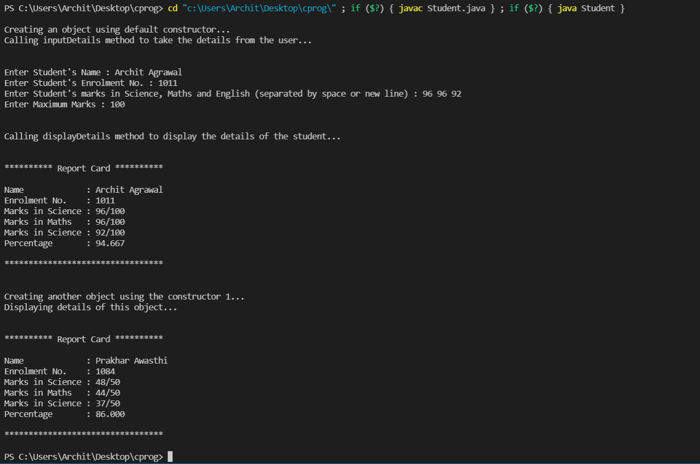

1. **Write a program in JAVA to check whether a string is palindrome or not.**

The code doesn’t take lowercase and uppercase as different characters i.e. “ARchiT” and “archit” are same when palindrome check is done.

*Class Diagram*

|  |
| --- |
| **IsPalindrome** |
| + IsPalindrome() |
| + isPalindrome(s: String): boolean  + main(args: String[]): void |

***Approach***: Take two integer variables ‘i’ and ‘j’. Initialise i = 0 i.e the first index of string and j = last index of string.

Check if the characters at i­th and jth index are same or not. If not, then the string will not be palindrome and ‘false’ will be returned. Otherwise, ‘i’ will be incremented by 1 and j will be decremented by 1. This check will happen while j is greater than i. Once j becomes equal to i, it means that the string is a palindrome, so true will be returned.

***CODE***

import java.util.*;

public class IsPalindrome{

    //method to find if string is palindrome or not

    public boolean isPalindrome(String s){

        int i = 0;

        int j = s.length() - 1;

        String str = s.toLowerCase();

        while(j > i){

            if(str.charAt(i) != str.charAt(j)){

                return false;

            }

            i++;

            j--;

        }

        return true;

    }

    public static void main(String[] args){

        System.out.println();

        Scanner sc = new Scanner(System.in);

        //creating an object of IsPalindrome class

        IsPalindrome isPalin = new IsPalindrome();

        System.out.print("Enter a string to check if it is palindrome or not : ");

        String s = sc.nextLine();

        if(isPalin.isPalindrome(s)){

            System.out.println("Input String is Palindrome");

        } else {

            System.out.println("Input String is not a Palindrome");

        }

        System.out.println();

    }

}

***OUTPUT***

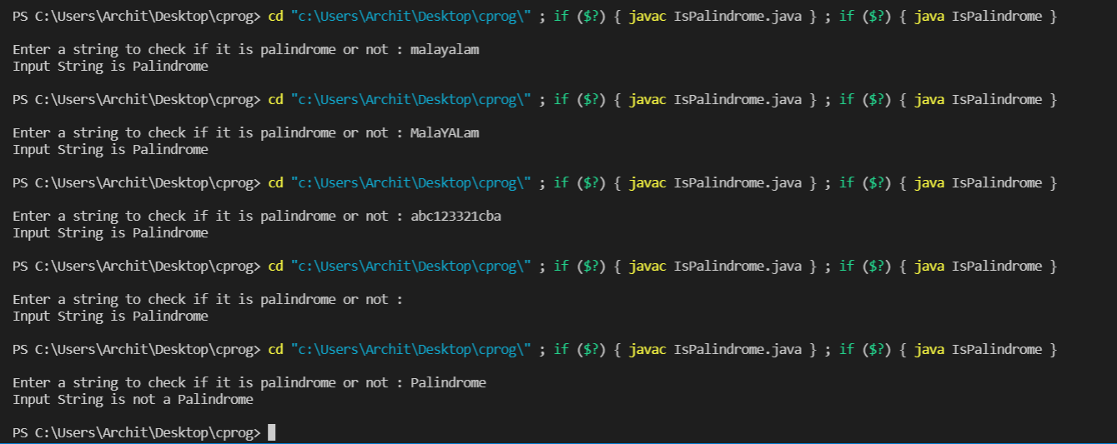

**Empty String is also a Palindrome.